**EES5310**

**Analyzing CMIP6 Climate Data for Flood Prediction**

**Celine Wehbe**

**INTRODUCTION**

This class project is a small initial step to a bigger research project. Its aim is to use climate data and incorporate them into a data-driven model to hopefully be able to predict when floods will occur, their duration, and their intensity. The following report deals with the data exploration part of the project.

**BACKGROUND – Climate Modeling**

Climate modeling uses modern computer models to reproduce the dynamics between the atmosphere, seas, and ice cover, and analyze how variables of this environment advance over time according to different scenarios of gas emissions and other components. It is used to study a wide range of phenomena, including temperature changes, sea level rise, ocean circulation, and the impact of human activities on the climate. By analyzing these models, analysts can determine causes and results of climate change, and offer mitigation choices aimed at reducing its impacts as well as awareness solutions. Climate modeling is a vital instrument used to address one of the most challenging problems of our time.

Determining a climate scenario depends on two factors: the Shared Economic Pathway (SSP) and the Representative Concentration Pathway (RCP).

**BACKGROUND – Shared Economic Pathways (SSPs)**

SSPs (Figure 1) predict how climate change will change in response to socio-economic indicators such as population, economy, land use, and energy change.

SSPs range from SSP1, which represents a sustainable and equitable world with strong international cooperation and low population growth, to SSP5, which represents a fragmented world with high population growth and a focus on national interests over global cooperation. The following is a more detailed description, taken from the National Oceanic and Atmospheric Administration (NOAA):

SSP1 Sustainability – Taking the Green Road (Low challenges to mitigation and adaptation)

The world shifts gradually, but pervasively, toward a more sustainable path, emphasizing more inclusive development that respects perceived environmental boundaries. Management of the global commons slowly improves, educational and health investments accelerate the demographic transition, and the emphasis on economic growth shifts toward a broader emphasis on human well-being. Driven by an increasing commitment to achieving development goals, inequality is reduced both across and within countries. Consumption is oriented toward low material growth and lower resource and energy intensity.

SSP2 Middle of the Road (Medium challenges to mitigation and adaptation)

The world follows a path in which social, economic, and technological trends do not shift markedly from historical patterns. Development and income growth proceeds unevenly, with some countries making relatively good progress while others fall short of expectations. Global and national institutions work toward but make slow progress in achieving sustainable development goals. Environmental systems experience degradation, although there are some improvements and overall the intensity of resource and energy use declines. Global population growth is moderate and levels off in the second half of the century. Income inequality persists or improves only slowly and challenges to reducing vulnerability to societal and environmental changes remain.

SSP3 Regional Rivalry – A Rocky Road (High challenges to mitigation and adaptation)

A resurgent nationalism, concerns about competitiveness and security, and regional conflicts push countries to increasingly focus on domestic or, at most, regional issues. Policies shift over time to become increasingly oriented toward national and regional security issues. Countries focus on achieving energy and food security goals within their own regions at the expense of broader-based development. Investments in education and technological development decline. Economic development is slow, consumption is material-intensive, and inequalities persist or worsen over time. Population growth is low in industrialized and high in developing countries. A low international priority for addressing environmental concerns leads to strong environmental degradation in some regions.

SSP4 Inequality – A Road Divided (Low challenges to mitigation, high challenges to adaptation)

Highly unequal investments in human capital, combined with increasing disparities in economic opportunity and political power, lead to increasing inequalities and stratification both across and within countries. Over time, a gap widens between an internationally-connected society that contributes to knowledge- and capital-intensive sectors of the global economy, and a fragmented collection of lower-income, poorly educated societies that work in a labor intensive, low-tech economy. Social cohesion degrades and conflict and unrest become increasingly common. Technology development is high in the high-tech economy and sectors. The globally connected energy sector diversifies, with investments in both carbon-intensive fuels like coal and unconventional oil, but also low-carbon energy sources. Environmental policies focus on local issues around middle and high income areas.

SSP5 Fossil-fueled Development – Taking the Highway (High challenges to mitigation, low challenges to adaptation)

This world places increasing faith in competitive markets, innovation and participatory societies to produce rapid technological progress and development of human capital as the path to sustainable development. Global markets are increasingly integrated. There are also strong investments in health, education, and institutions to enhance human and social capital. At the same time, the push for economic and social development is coupled with the exploitation of abundant fossil fuel resources and the adoption of resource and energy intensive lifestyles around the world. All these factors lead to rapid growth of the global economy, while global population peaks and declines in the 21st century. Local environmental problems like air pollution are successfully managed. There is faith in the ability to effectively manage social and ecological systems, including by geo-engineering if necessary.

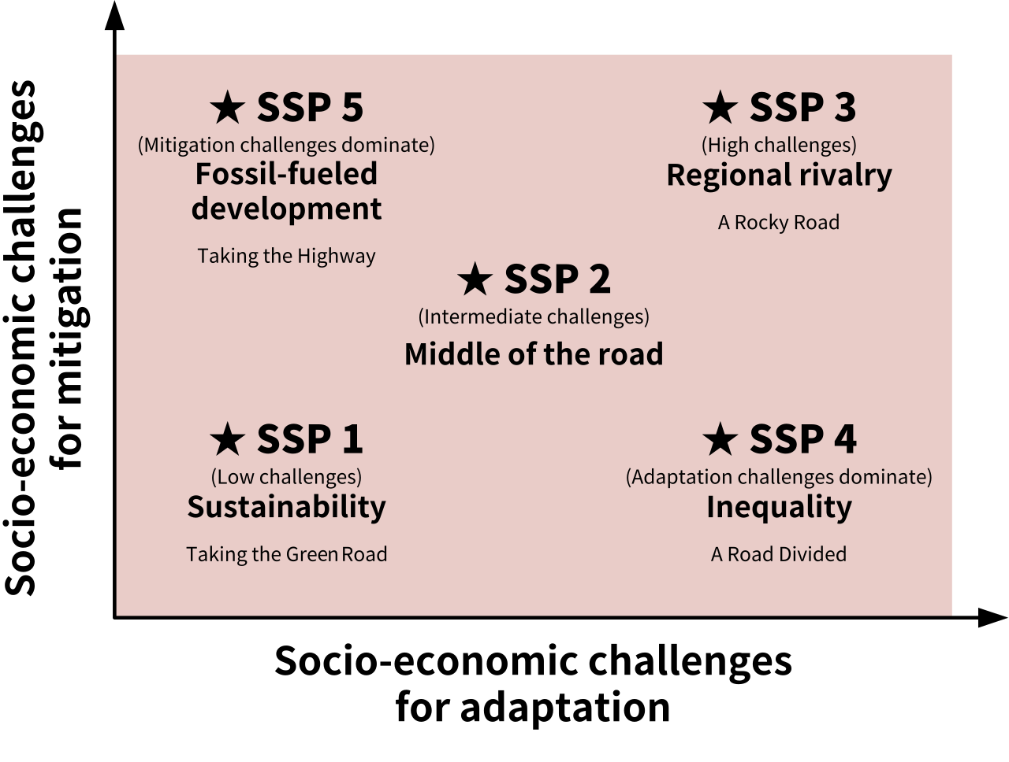

Figure 1: SSP Definition

**BACKGROUND – Representative Concentration pathways (RCPs)**

RCPs (Figure 2) are GHG concentration trajectories adopted by the IPCC. RCPs quantify future GHG concentrations and the radiative forcing due to increases in climate change pollution.

radiative forcing

Figure 2: RCP Definition

**BACKGROUND – Study Area & Timeline**

Although this project aims to be reproducible to all inland waterways, this case study focuses on the Upper Mississippi River, or UMR (Figure 3). The analysis timeline will be from 2015 to 2100.

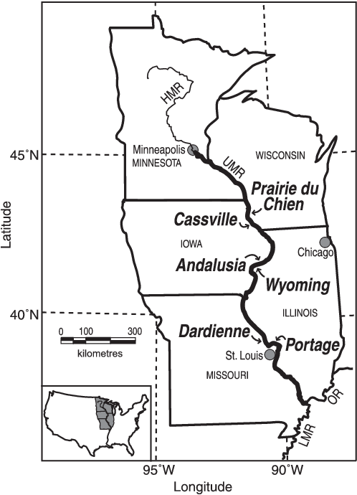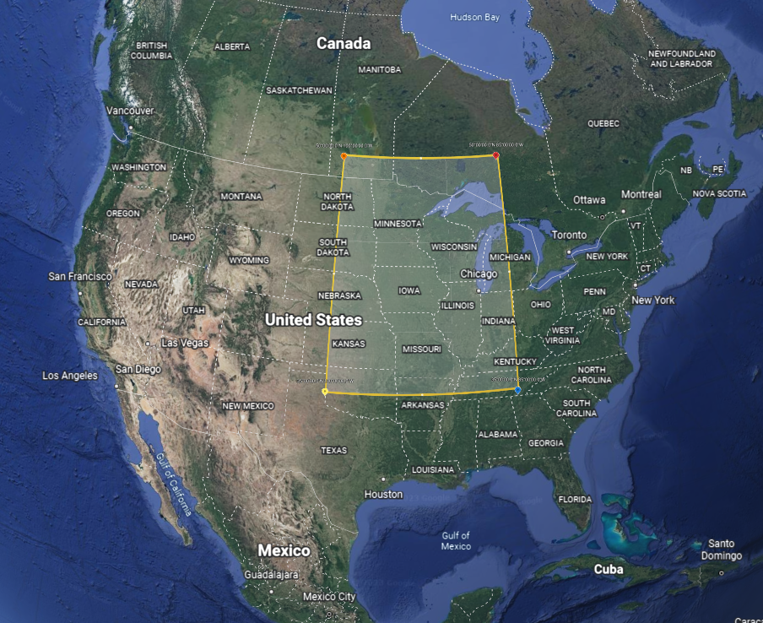

Figure 3: Study Area

**SCIENTIFIC QUESTIONS**

Main Project Objective:develop a data-driven approach to evaluate impacts of climate-related disruptions, such as flooding, along inland waterways, in this case study, the Upper Mississippi River.

Questions:

* How does the change in radiative forcing due to increased pollution affect precipitations? What about changes in population, economy, land use, and energy use?
* How do these changes vary over the years? Over the seasons?
* Geographically, where are these changes most prominent?
* How frequent are precipitation levels that can cause floods?

**METHODS – CMIP6**

The climate model tool that is used in this project is The Coupled Model Intercomparison Project Phase 6 (CMIP6).

The first step is to select variables to be studied. In our cases, we want to study precipitation and snowfall, as these are two important factors of flooding. In CMIP6, these variables are ‘pr’ and ‘snw’. Then, the temporal and spatial scales are selected. To balance between accuracy and computational power, we chose the temporal scale as daily and the spatial scale as 100 km pixels. Finally, the climate scenarios that need to be studied are selected. We chose the most common scenarios that are used in the literature:

ssp126

Based on SSP1 and RCP 2.6. Future scenario with low radiative forcing by the end of century (net zero around 2075). Estimated warming of 1.4°C by 2100.

ssp245

Based on SSP2 and RCP 4.5. Future scenario with medium radiative forcing by the end of century (around current level until 2050, then decrease). Estimated warming of 2.7°C by 2100.

ssp370

Based on SSP3 and RCP 7.0. Future scenario with high radiative forcing by the end of century (double). Estimated warming of 3.6°C by 2100.

ssp585

Based on SSP5 and RCP 8.5. Future scenario with very high radiative forcing by the end of century (triple). Estimated warming of 4.4°C by 2100.

**RESULTS**

For brevity, we only display precipitation results in this report.

The average daily precipitation for each year along the entire UMR area for each scenario is shown below (Figure 4). We also show the 90th percentile (Figure 5), and the anomaly, using 2015 as a baseline (Figure 6).

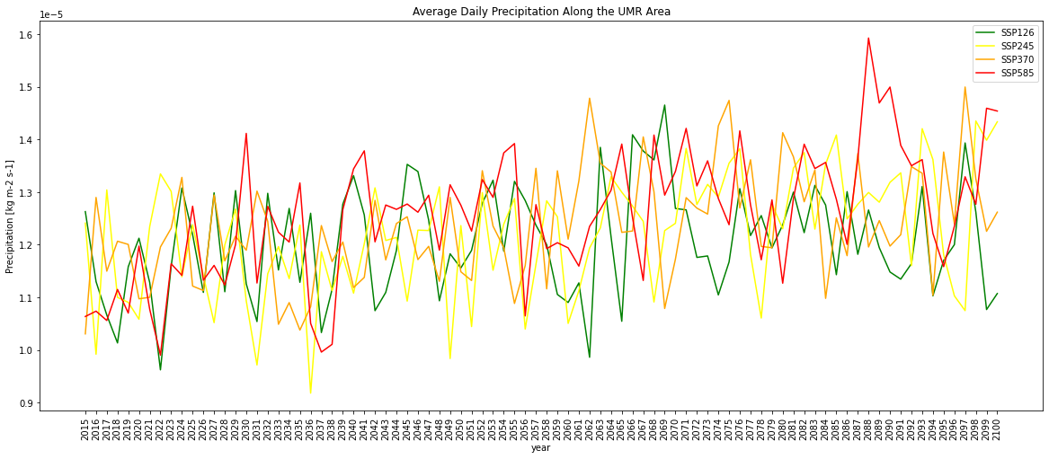

Figure 4

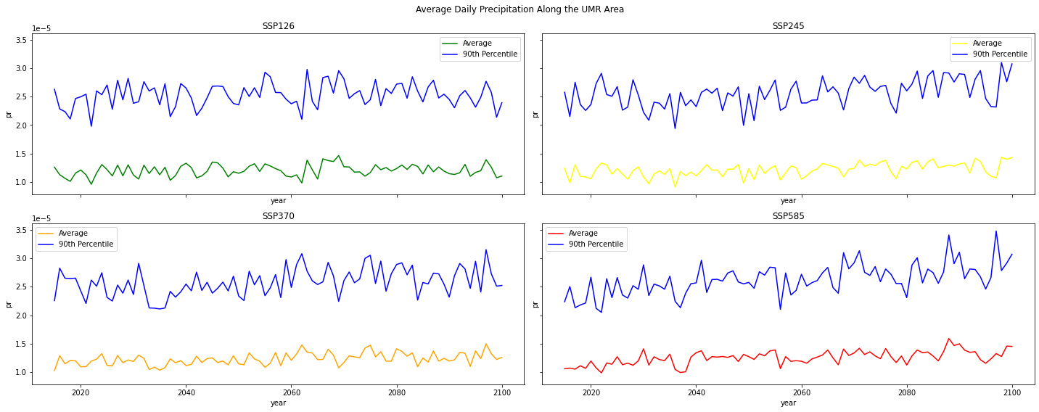

Figure 5

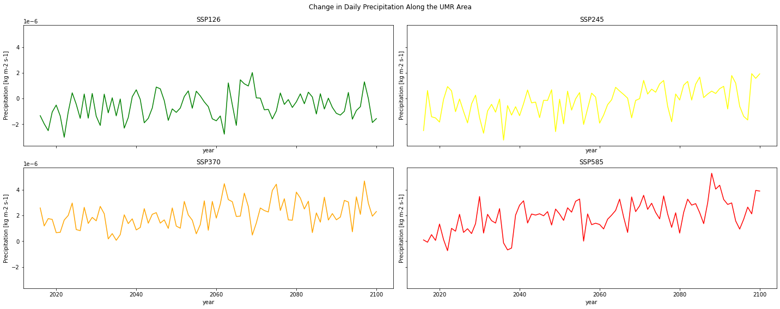

Figure 6

Moreover, the average daily precipitation for the years 2015, 2050 and 2100 are shown on the UMR area for each scenario (Figure 7). The anomaly, using 2015 as a baseline is also calculated (Figure 8). The precipitation is also analyzed seasonally (Figure 9), as well as the seasonal anomaly from the 2015 baseline (Figure 10 and 11). The seasonal variation is shown with its 90th percentile (Figure 12) as well as the anomaly from the 2015 baseline (Figure 13). Finally, we want to see the frequency of those high precipitation amounts that cause floods. These are the tails of the histograms of precipitation. The monthly histograms for each scenario were determined (Figure 14, 15, 16 and 17).

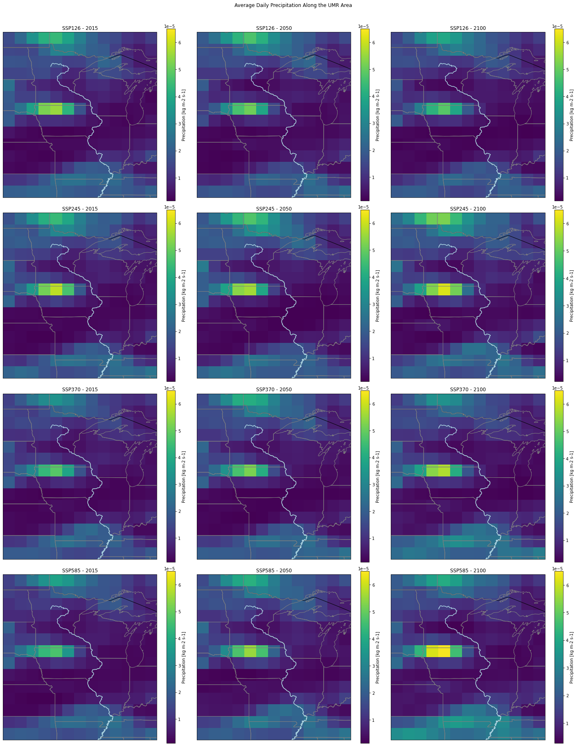

Figure 7

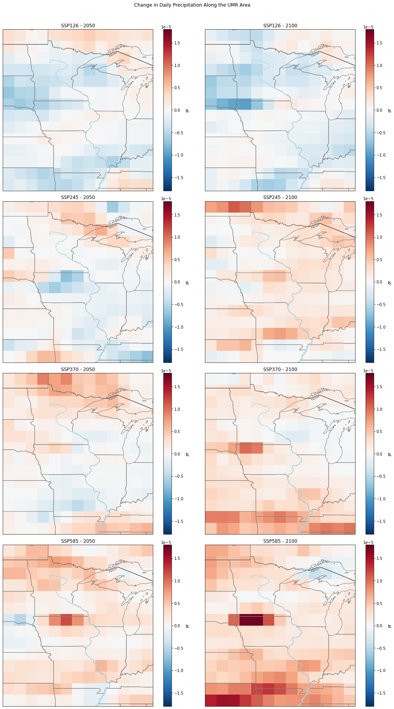

Figure 8

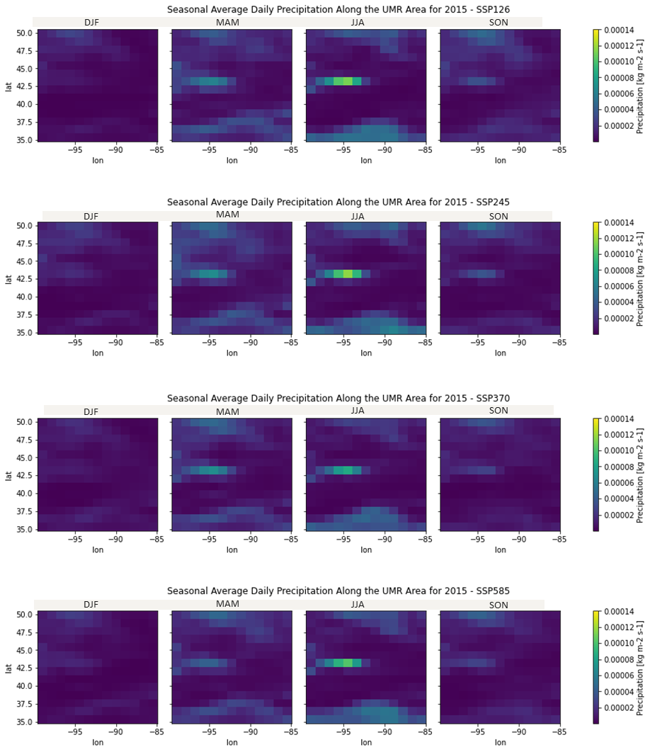

Figure 9

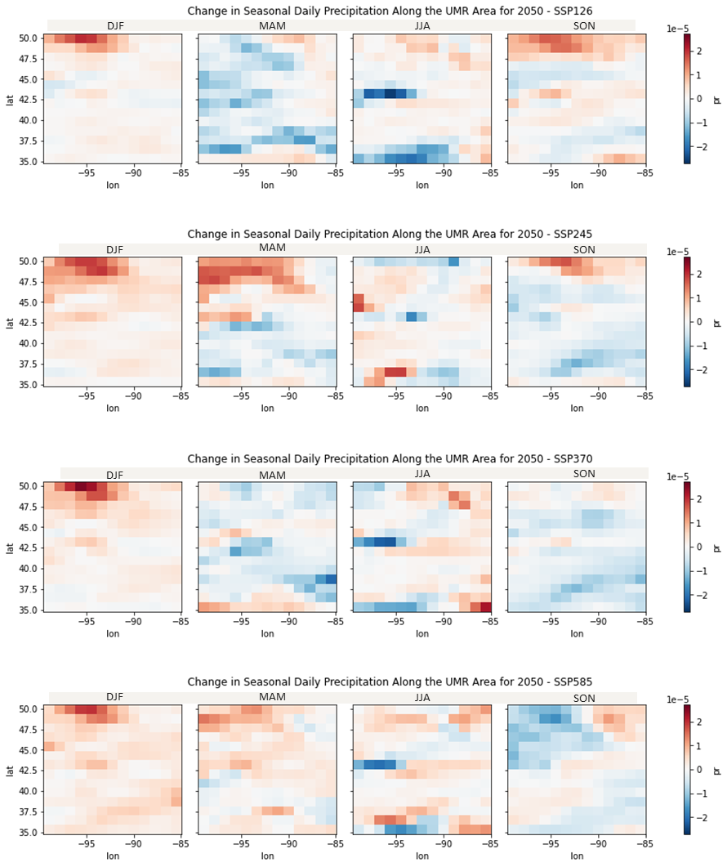

Figure 10

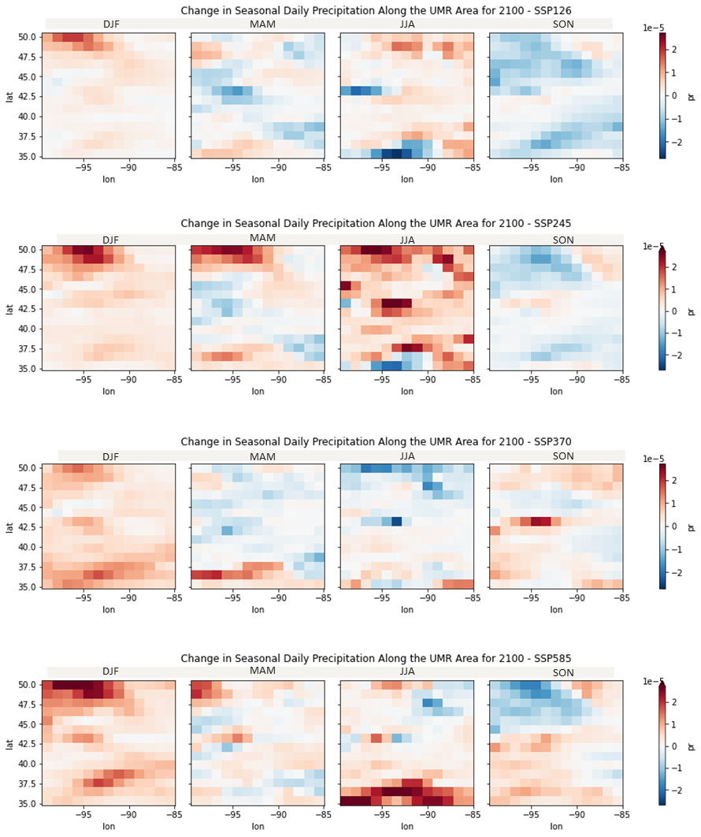

Figure 11

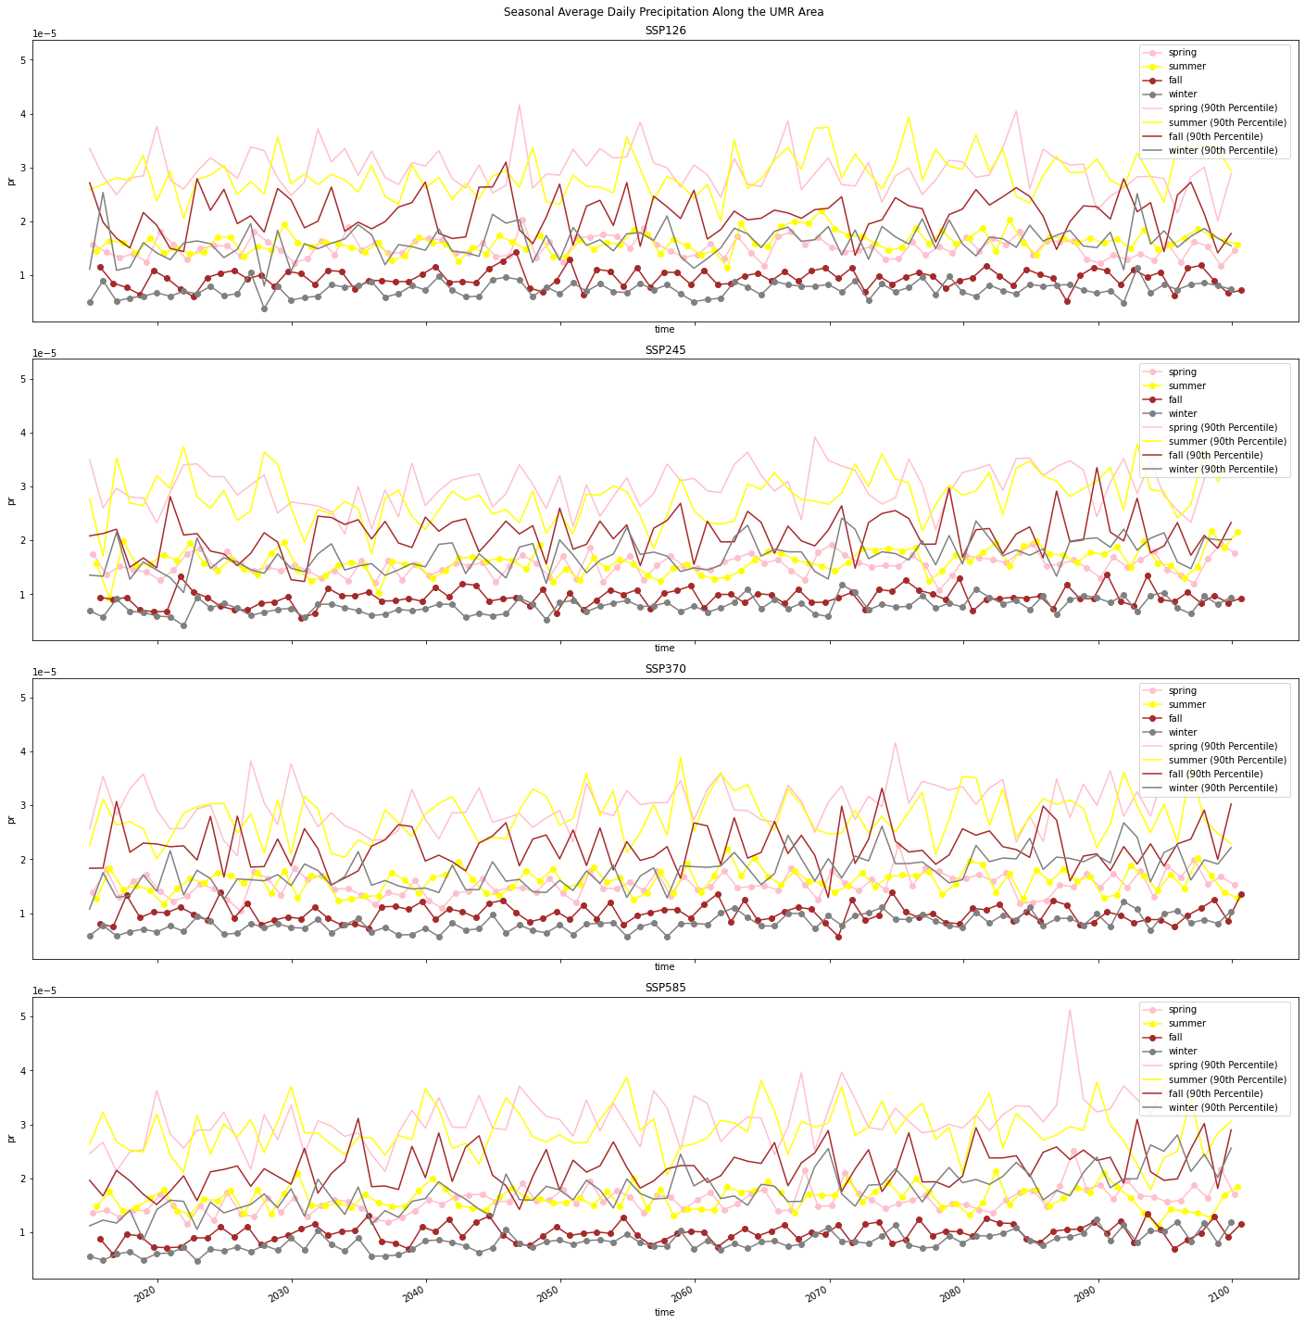

Figure 12

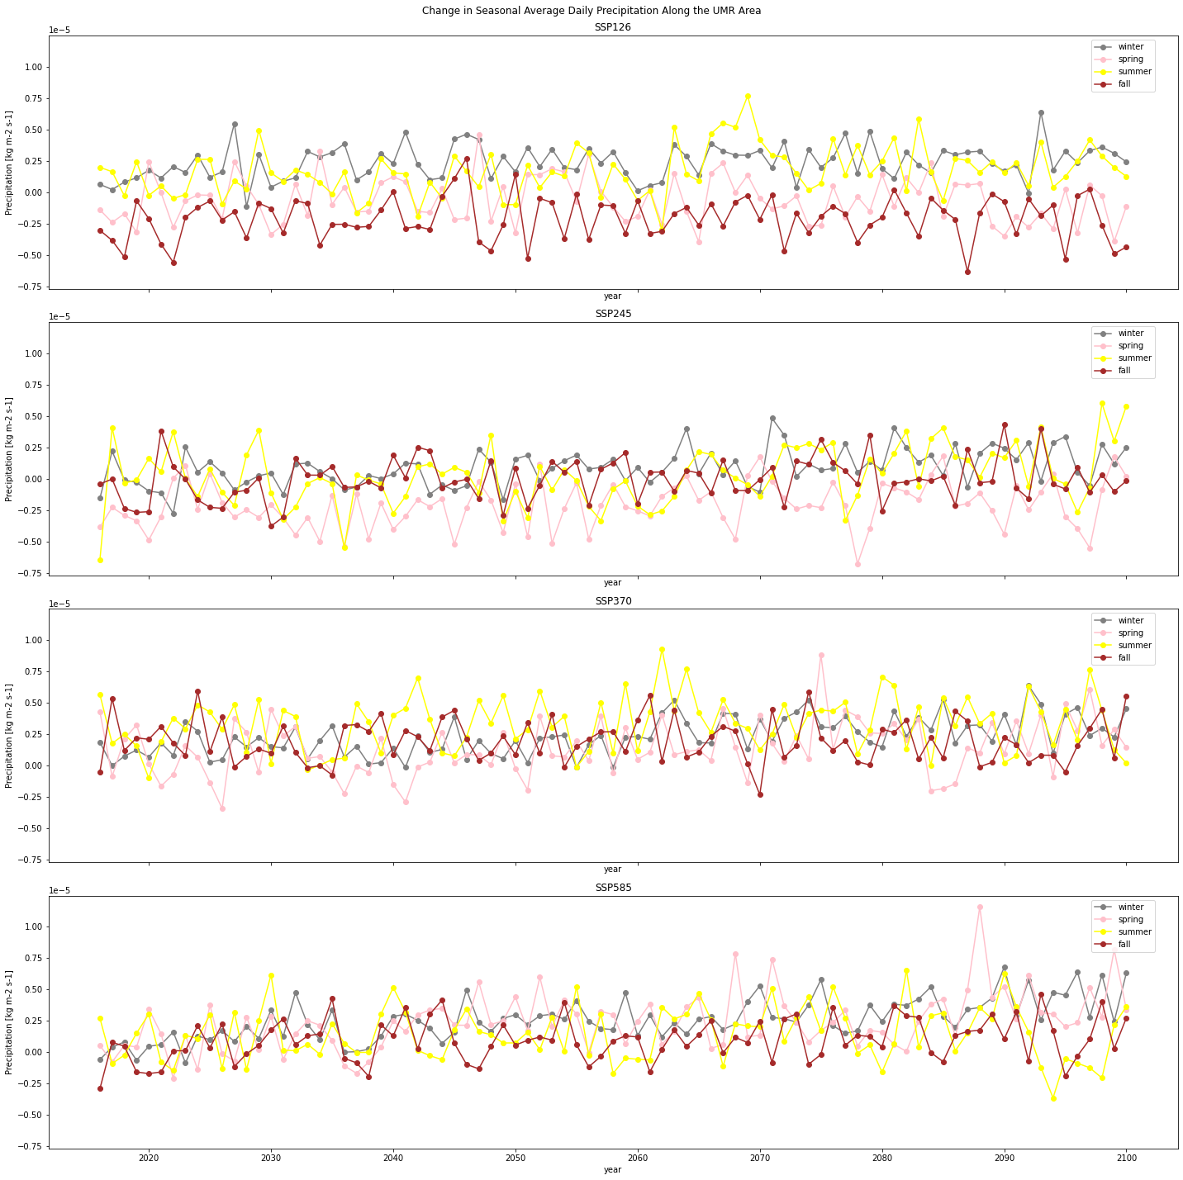

Figure 13

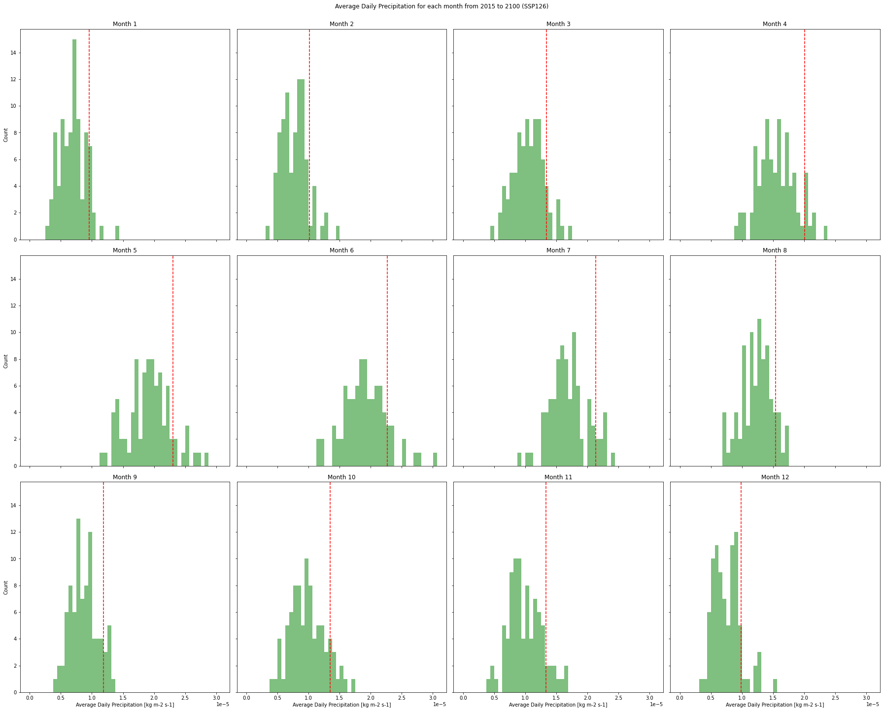

Figure 14

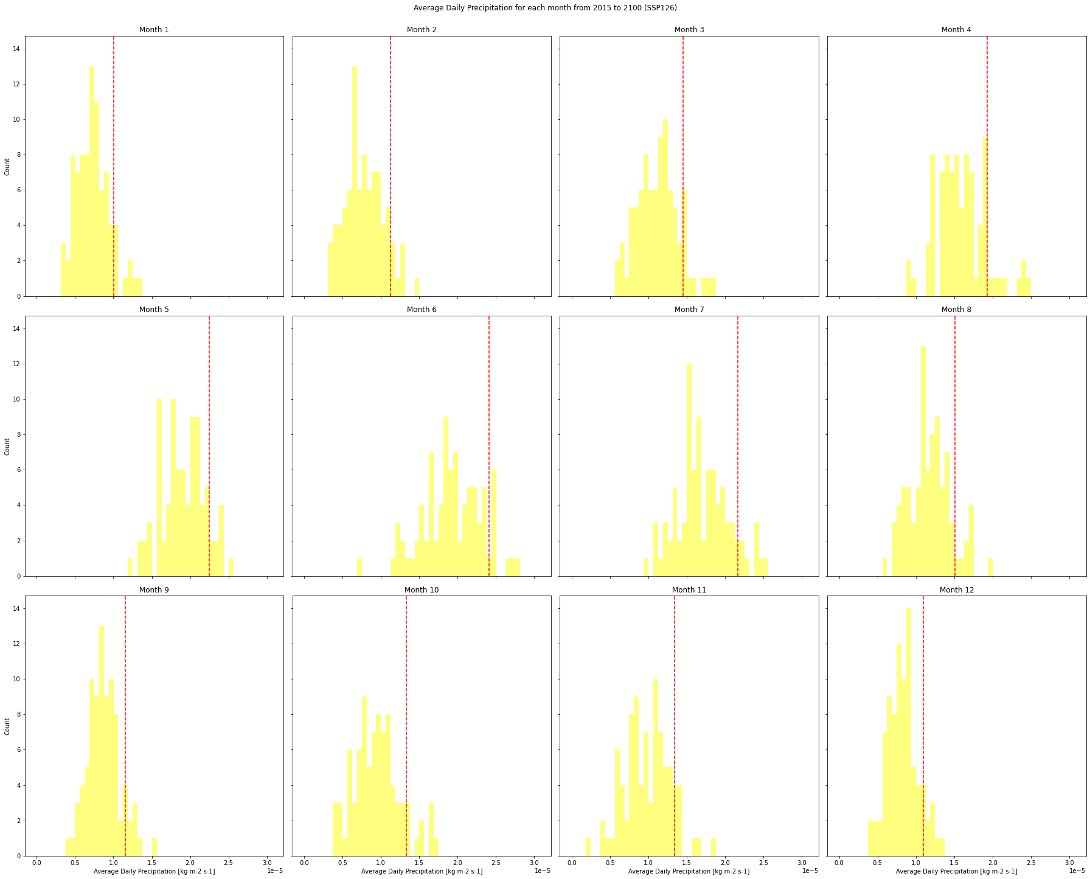

Figure 15

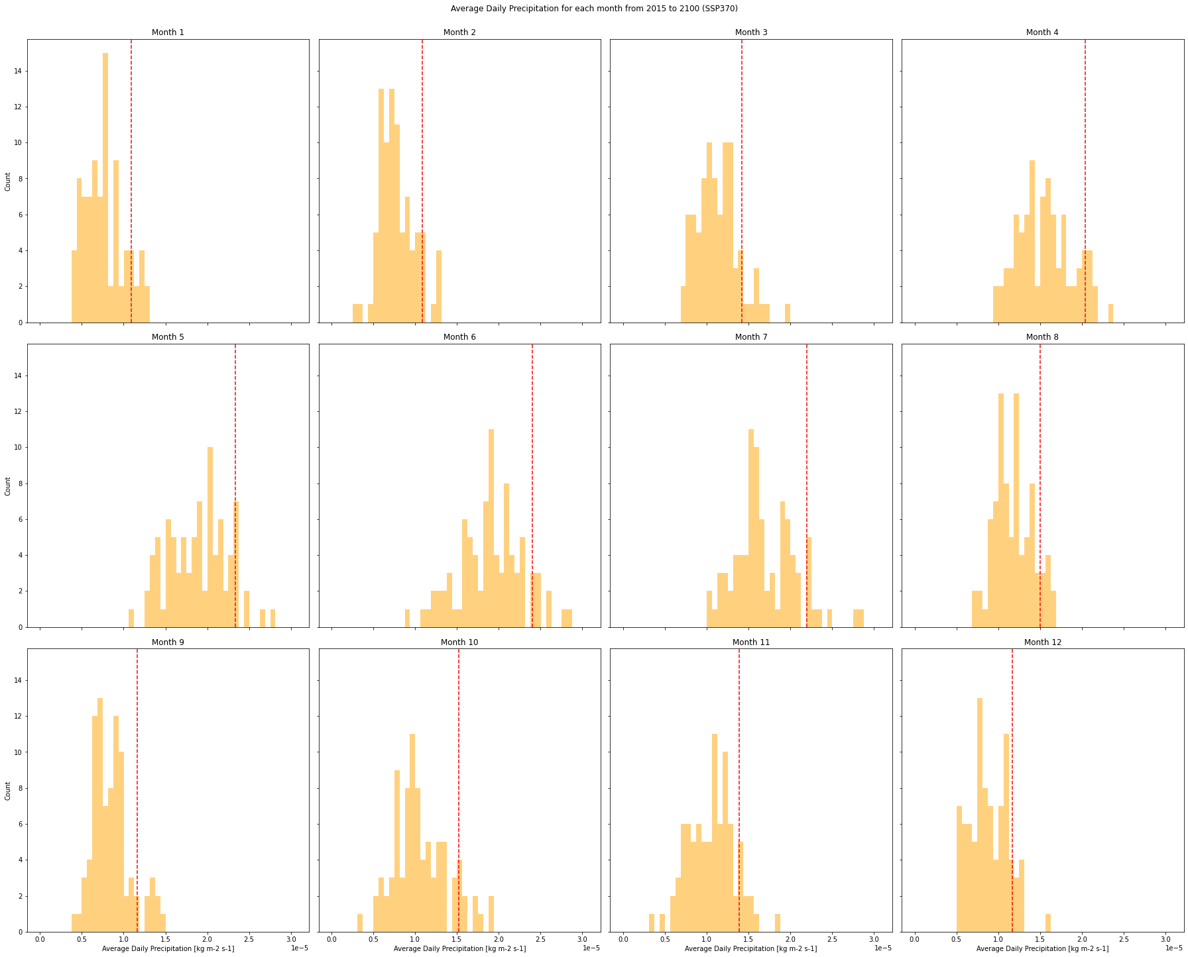

Figure 16

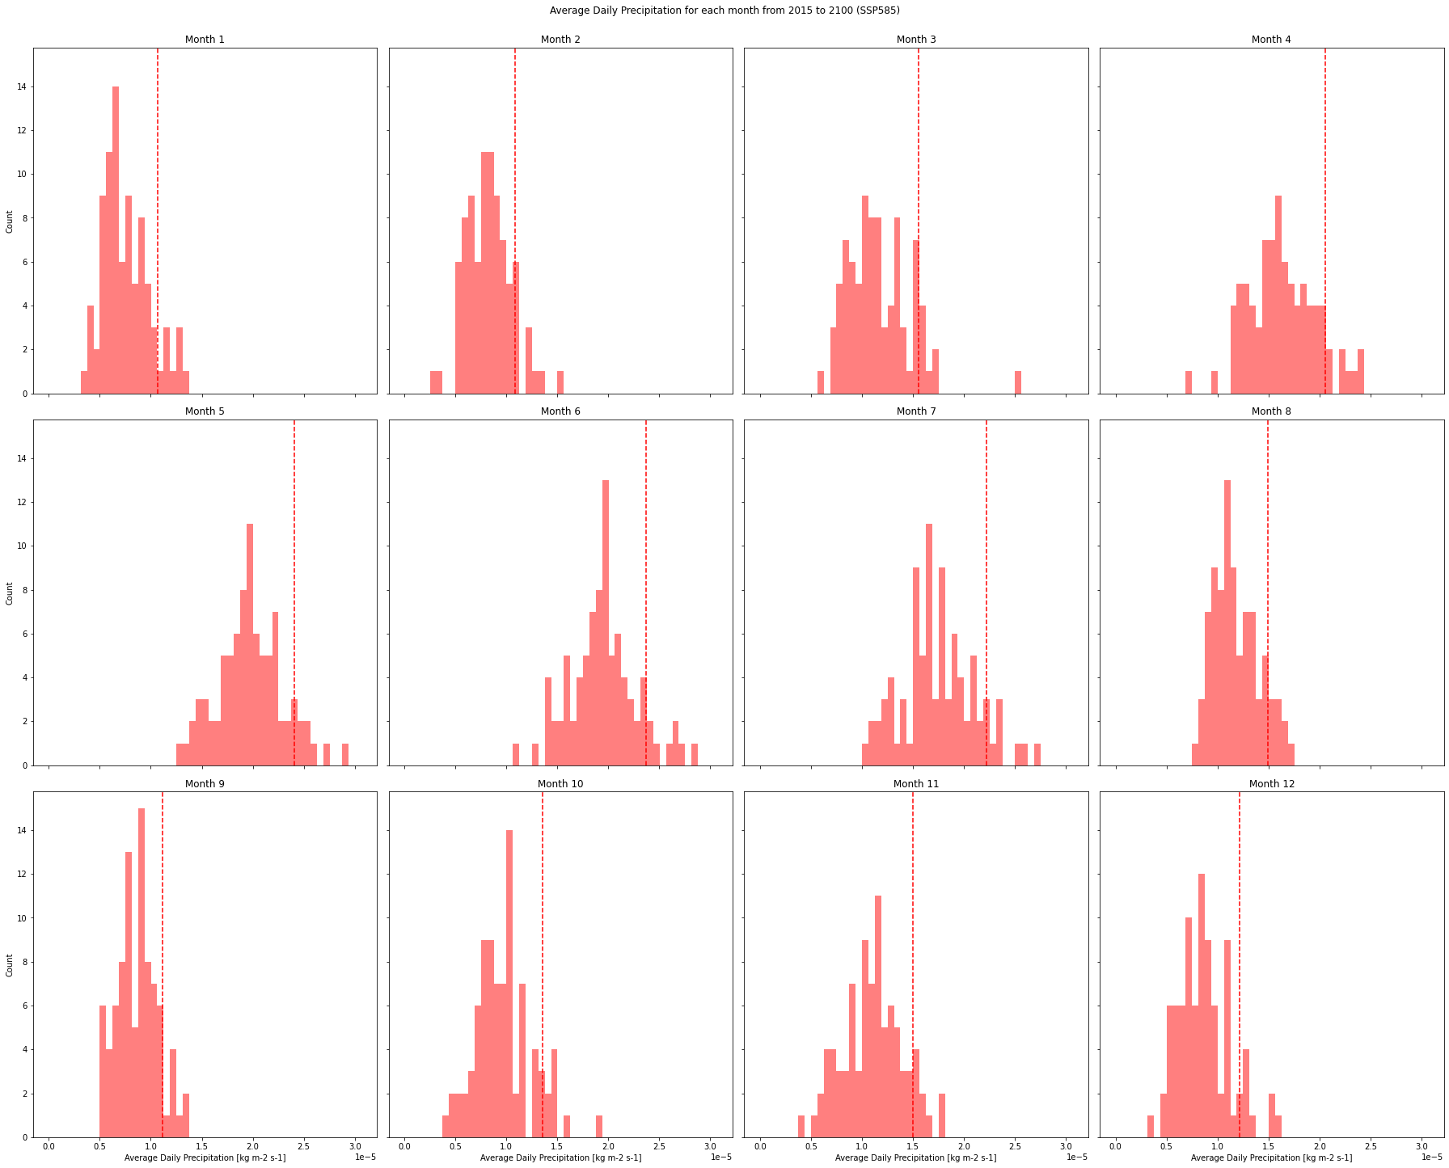

Figure 17